|  |  |
| --- | --- |
| **AP Computer Science** | **GraphicsLab05 Java Assignment** |
| **The "Random Circles" Program** | **80 & 100 Point Versions** |
| **Assignment Purpose:**  This program requires knowledge of randomness, graphics commands and compound and nested control structures. | |

In this program the student display starts by displaying three squares. The squares are colored red, green and blue, which are the primary computer colors. This program needs to display circles with random colors. Each circle is meant to be displayed next to the appropriate square. With random colors that may seem odd, but each circle has a dominant color. Check the three color values and that highest color value determines the row for the display.

|  |
| --- |
| **GraphicsLab05st.java Provided Student File** |
| // GraphicsLab05st.java  // This is the student, starting version of the GraphicsLab05 assignment.  import java.awt.*;  import java.applet.*;  import java.util.*;  public class GraphicsLab05st extends Applet  {  public void paint(Graphics g)  {  int circleCount = 40;  Circles circles = new Circles(g,circleCount);  }  }  class Circles  {  private int circleCount;  private Random rnd;  private Color randomColor;  private int colorRow;  private int redCount, greenCount, blueCount;  public Circles(Graphics g,int c)  {  rnd = new Random(12345);  circleCount = c;  redCount = 1;  greenCount = 1;  blueCount = 1;  drawSquares(g);  for (int k = 1; k <= circleCount; k++)  drawRandomCircle(g);  }  public void drawSquares(Graphics g)  {  g.setColor(Color.red);  g.fillRect(10,100,30,30);  g.setColor(Color.green);  g.fillRect(10,250,30,30);  g.setColor(Color.blue);  g.fillRect(10,400,30,30);  }  public void drawRandomCircle(Graphics g)  {  }  public void getRandomColor()  {  }  } |

**80-Point Version**

If you see a printout of this assignment, look at it on the computer. The colors will help. For the 90-point version you need to identify the dominating color and then display the circle. This only needs to work for one row. If there are too many circles, just let them run off the screen.

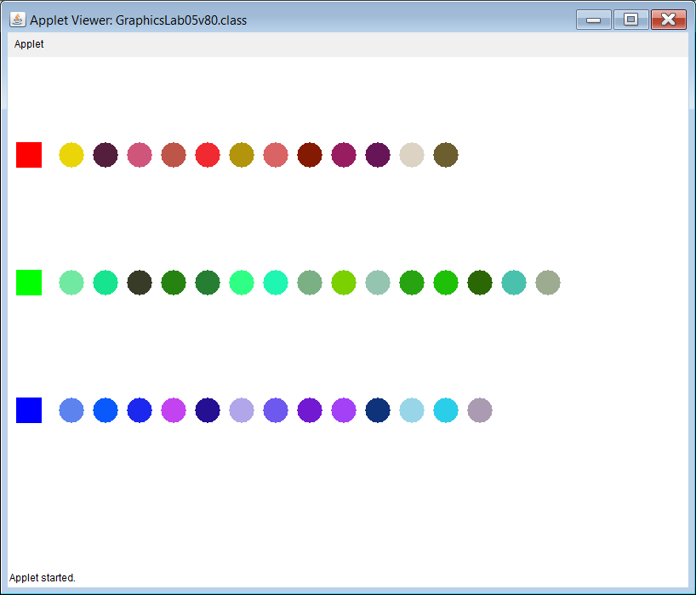

**100-Point Version**

The 100-point version does not let the circles run off the screen. After 17 circles are displayed a second row is started. Only two rows are necessary. You do not need to determine how to handle a possible third or fourth row.

